**CS 640-01**

**ADVANCED DATABASE SYSTEM**

**ASSIGNMENT - 04**

**Question 1(chapter 7)**

**Specify the following additional queries on the following database in SQL. Show the query results if applied to the following database.**

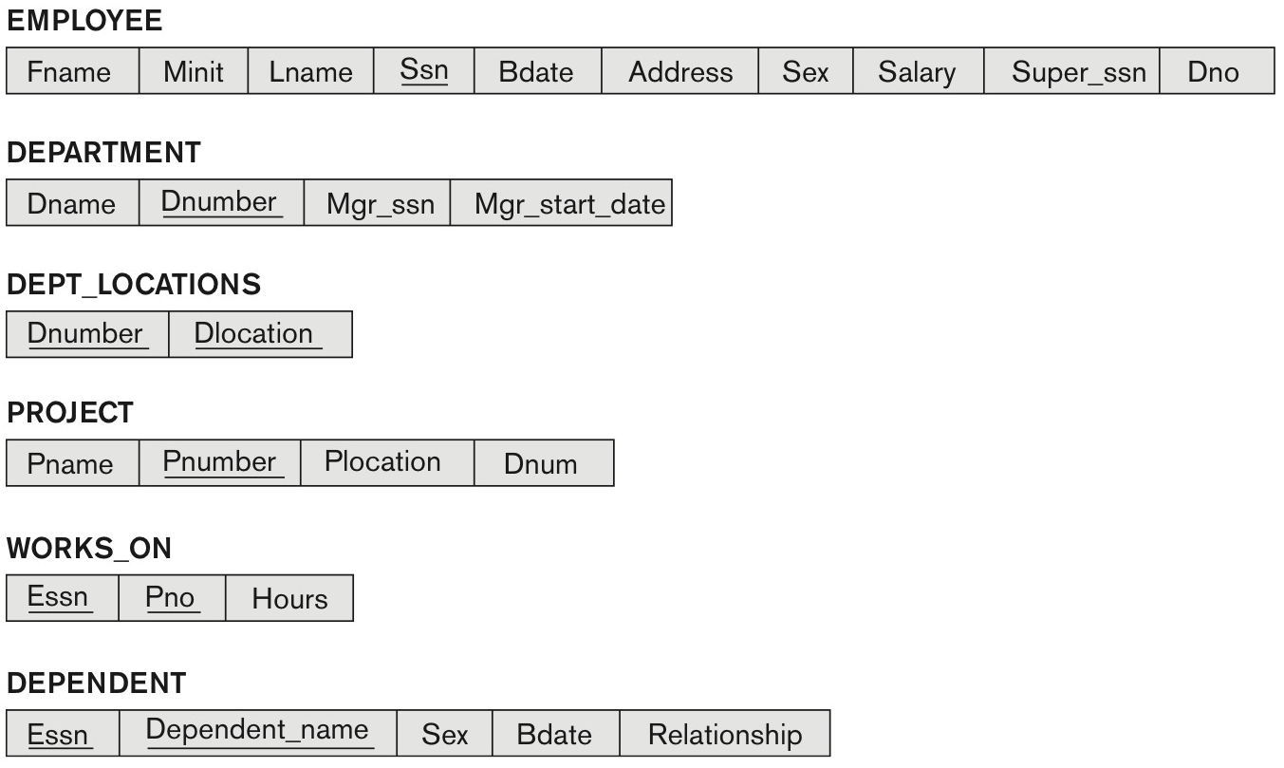

3 tables list tuples under Employee, Department and Department locations.
Table 1 titled, employee has 8 rows and 9 columns. The columns have the following headings from left to right. F name, M i n i t, L name, S s n, B date, Address, Sex, Salary, Super s s n, D n o. The row entries are as follows. Row 1. F name, John. M i n i t, B. L name, Smith. S s n, 123 45 6789. B date, 19 65 01 09. Address, 731 Fondren, Houston, T X. Sex, M. Salary, 30,000. Super s s n, 333 44 5555. D n o, 5. Row 2. F name, Franklin. M i n i t, T. L name, Wong. S s n, 333 44 5555. B date, 19 55 12 08. Address, 638 Voss, Houston, T X. Sex, M. Salary, 40,000. Super s s n, 888 66 5555. D n o, 5. Row 3. F name, Alicia. M i n i t, J. L name, Zelaya. S s n, 999 88 7777. B date, 19 68 01 19. Address, 3321 Castle, Spring, T X. Sex, F. Salary, 25,000. Super s s n, 987 65 4321. D n o, 4. Row 4. F name, Jennifer. M i n i t, S. L name, Wallace. S s n, 987 65 4321. B date, 19 41 06 20. Address, 291 Berry, Bellaire, TX. Sex, F. Salary, 43,000. Super s s n, 888 66 5555. D n o, 4. Row 5. F name, Ramesh. M i n i t, K. L name, Narayan. S s n, 666 88 4444. B date, 19 62 09 15. Address, 975 Fire Oak, Humble, TX. Sex, M. Salary, 38,000. Super s s n, 333 44 5555. D n o, 5. Row 6. F name, Joyce. M i n i t, A. L name, English. S s n, 453 45 3453. B date, 19 72 07 31. Address, 5631 Rice, Houston, TX. Sex, F. Salary, 25,000. Super s s n, 333 44 5555. D n o, 5. Row 7. F name, Ahmad. M i n i t, V. L name, Jabbar. S s n, 888 66 5555. B date, 19 69 03 29. Address, 980 Dallas, Houston, TX. Sex, M. Salary, 25,000. Super s s n, 987 65 4321. D n o, 4. Row 8. F name, James. M i n i t, E. L name, Borg. S s n, 987 98 7987. B date, 19 37 11 10. Address, 450 Stone, Houston, T X. Sex, M. Salary, 55,000. Super s s n, NULL. D n o, 1. Table 2 titled, Department has 3 rows and 3 columns. The columns have the following headings from left to right. D name, D number, M g r s s n, M g r start date. The row entries are as follows. Row 1. D name, Research. D number, 5. M g r s s n, 333 44 5555. M g r start date, 19 88 05 22. Row 2. D name, Administration. D number, 4. M g r s s n, 987 65 4321. M g r start date, 19 95 01 01. Row 3. D name, Headquarters. D number, 1. M g r s s n, 888 66 5555. M g r start date, 19 81 06 19. Table 3 titled, DEPT LOCATIONS has 5 rows and 2 columns. The columns have the following headings from left to right. D number, D locations. The row entries are as follows. Row 1. D number, 1. D locations, Houston. Row 2. D number, 4. D locations, Stafford. Row 3. D number, 5. D locations, Bellaire. Row 4. D number, 5. D locations, Sugarland. Row 5. D number, 5. D locations, Houston.

3 tables list the database of the entities Works ON, Project and Dependent. Table 1 titled, WORKS ON. The Table has 16 rows and 3 columns. The columns have the following headings from left to right. E s s n, P n o, Hours. The row entries are as follows. Row 1. E s s n, 123 45 6789. P n o, 1. Hours, 32.5. Row 2. E s s n, 123 45 6789. P n o, 2. Hours, 7.5. Row 3. E s s n, 666 88 4444. P n o, 3. Hours, 40.0. Row 4. E s s n, 453 45 3453. P n o, 1. Hours, 20.0. Row 5. E s s n, 453 45 3453. P n o, 2. Hours, 20.0. Row 6. E s s n, 333 44 5555. P n o, 2. Hours, 10. Row 7. E s s n, 333 44 5555. P n o, 3. Hours, 10. Row 8. E s s n, 333 44 5555. P n o, 10. Hours, 10. Row 9. E s s n, 333 44 5555. P n o, 20. Hours, 10. Row 10. E s s n, 999 88 7777. P n o, 30. Hours, 30. Row 11. E s s n, 999 88 7777. P n o, 10. Hours, 10. Row 12. E s s n, 987 98 7987. P n o, 10. Hours, 35. Row 13. E s s n, 987 98 7987. P n o, 30. Hours, 5. Row 14. E s s n, 987 65 4321. P n o, 30. Hours, 20. Row 15. E s s n, 987 65 4321. P n o, 20. Hours, 15. Row 16. E s s n, 888 66 5555. P n o, 20. Hours, NULL. Table 2 titled, Project. The Table has 6 rows and 3 columns. The columns have the following headings from left to right. P name, P number, P location, D n u m. The row entries are as follows. Row 1. P name, Product X. P number, 1. P location, Bellaire. D n u m, 5. Row 2. P name, Product Y. P number, 2. P location, Sugarland. D n u m, 5. Row 3. P name, Product Z. P number, 3. P location, Houston. D n u m, 5. Row 4. P name, Computerization. P number, 10. P location, Stafford. D n u m, 4. Row 5. P name, Reorganization. P number, 20. P location, Houston. D n u m, 1. Row 6. P name, New benefits. P number, 30. P location, Stafford. D n u m, 4. Table 3 titled, Dependent. The Table has 7 rows and 4 columns. The columns have the following headings from left to right. E s s n, Dependent name, sex, B date, Relationship. The row entries are as follows. Row 1. E s s n, 333 44 5555. Dependent name, Alice. sex, F. B date, 19 86 04 05. Relationship, Daughter. Row 2. E s s n, 333 44 5555. Dependent name, Theodore. sex, M. B date, 19 83 10 25. Relationship, Son. Row 3. E s s n, 333 44 5555. Dependent name, Joy. sex, F. B date, 19 58 05 03. Relationship, Spouse. Row 4. E s s n, 987 65 4321. Dependent name, Abner. sex, M. B date, 19 42 02 28. Relationship, Spouse. Row 5. E s s n, 123 45 6789. Dependent name, Michael. sex, M. B date, 19 88 01 04. Relationship, Son. Row 6. E s s n, 123 45 6789. Dependent name, Alice. sex, F. B date, 19 42 12 30. Relationship, Daughter. Row 7. E s s n, 123 45 6789. Dependent name, Elizabeth. sex, F. B date, 19 67 05 05. Relationship, Spouse.

**(a) For each department whose average employee salary is more than $30,000, retrieve the department name and the number of employees working for that department.**

SELECT Dname, Dnumber, Count(*) as total_no_of_employee

FROM DEPARTMENT, EMPLOYEE

WHERE Dnumber = Dno

GROUP BY DEPARTMENT.Dname

HAVING AVG(Salary) > 30000

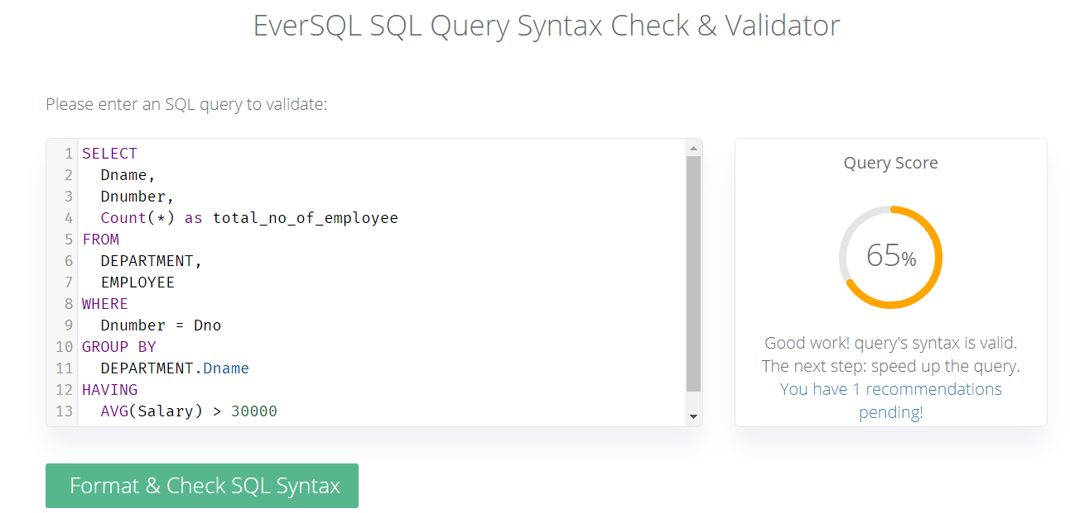

*Result:*

|  |  |  |
| --- | --- | --- |
| **Dname** | **Dnumber** | **total_no_of_employee** |
| Research | 5 | 4 |
| Administration | 4 | 3 |
| Headquarters | 1 | 1 |

**(b) Suppose we want the number of *male* employees in each department rather than all employees (as in Exercise 5.4a). Can we specify this query in SQL? Why or why not?**

Yes, it can be specified in query by using join condition between two tables as shown below:

SELECT dep.Dname, dep.Dnumber, COUNT(*) male_employees

FROM DEPARTMENT dep LEFT JOIN EMPLOYEE emp ON dep.Dnumber = emp.Dno

WHERE emp.sex = 'M' GROUP BY dep.Dname HAVING AVG(emp.Salary) > 30000;

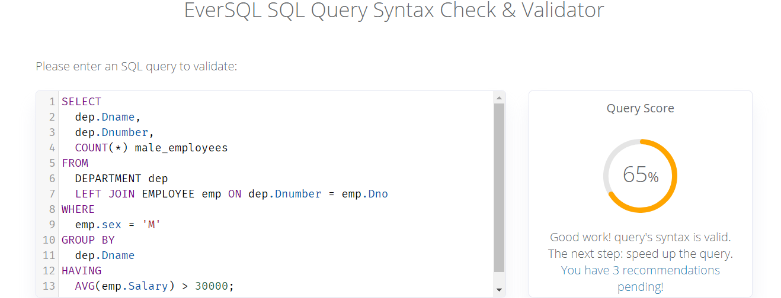

*RESULT*:

|  |  |  |
| --- | --- | --- |
| **Dname** | **Dnumber** | **male_employees** |
| Research | 5 | 3 |
| Administration | 4 | 1 |
| Headquarters | 1 | 1 |

**Question 2(chapter 7) Specify the following queries in SQL on the database schema of the following figure.**

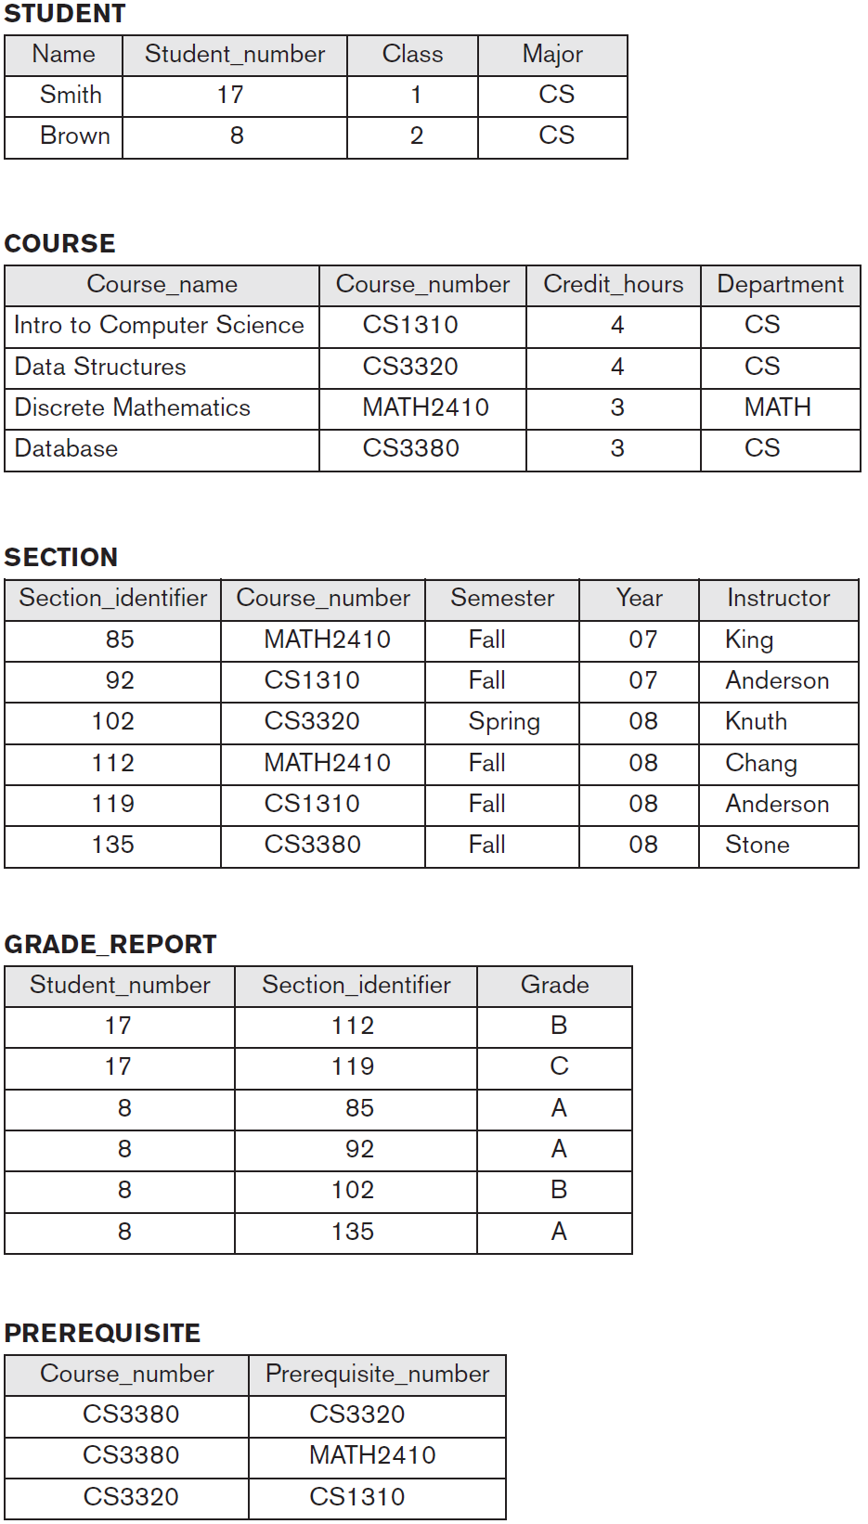

1. **Retrieve the names and major departments of all straight-A students (students who have a grade of A in all their courses).**

SELECT Name, Major

FROM STUDENT WHERE NOT EXISTS (SELECT * FROM GRADE_REPORT

WHERE GRADE_REPORT.StudentNumber = STUDENT.StudentNumber AND NOT(Grade = 'A') )

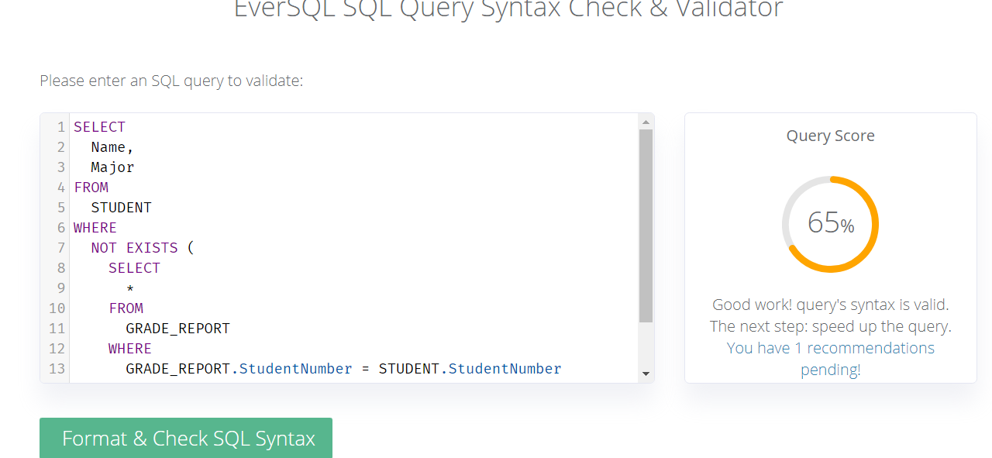

**(b) Retrieve the names and major departments of all students who do not have any grade of A in any of their courses.**

SELECT Name, Major FROM STUDENT WHERE NOT EXISTS (

SELECT * FROM GRADE_REPORT WHERE GRADE_REPORT.StudentNumber = STUDENT.StudentNumber

AND Grade = 'A' )



**Question 3( Chapter 7) In SQL, specify the following queries on the database specified in the following figure using the concept of nested queries and the concepts described in this chapter.**



1. **Retrieve the names of all employees who work in the department that has the employee with the highest salary among all employees.**

SELECT FNAME, LNAME FROM EMPLOYEE WHERE Dno = (

SELECT Dno FROM EMPLOYEE WHERE Salary = (SELECT MAX(Salary)

FROM EMPLOYEE))

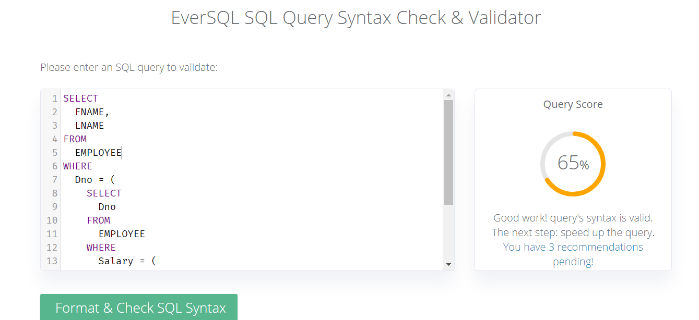

1. **Retrieve the names of all employees whose supervisor’s supervisor has '888665555' for Ssn.**

SELECT Fname, Lname FROM EMPLOYEE WHERE EMPLOYEE.Super_ssn = ( SELECT Ssn FROM EMPLOYEE WHERE EMPLOYEE.Super_ssn = '888665555' );

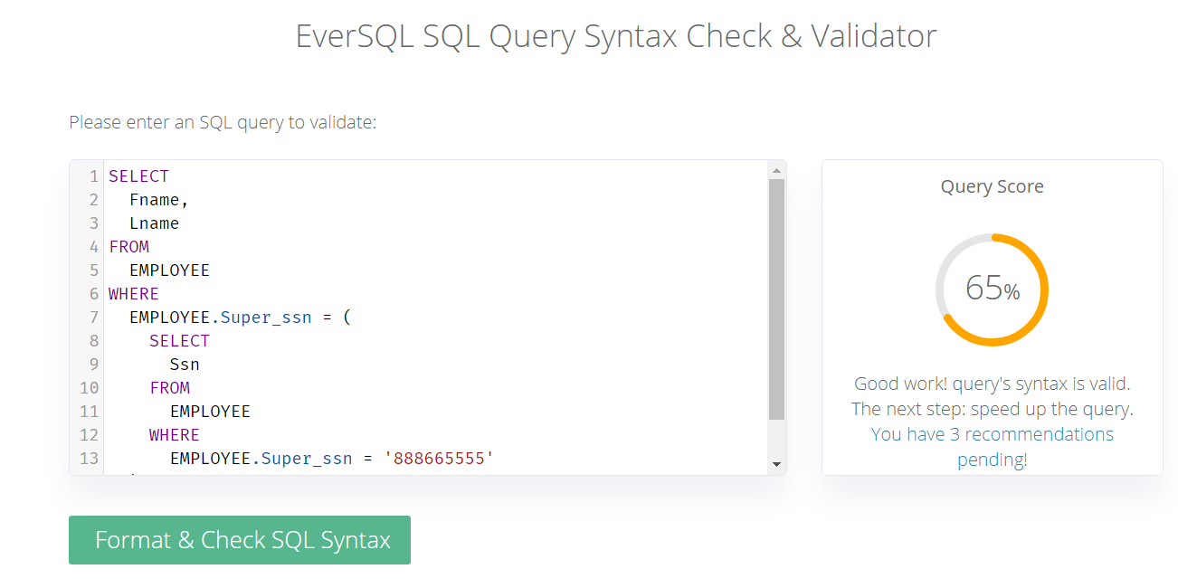

1. **Retrieve the names of employees who make at least $10,000 more than the employee who is paid the least in the company.**

SELECT Fname, Lname FROM EMPLOYEE WHERE Salary >= 10000 + (

SELECT MIN(Salary) FROM EMPLOYEE)

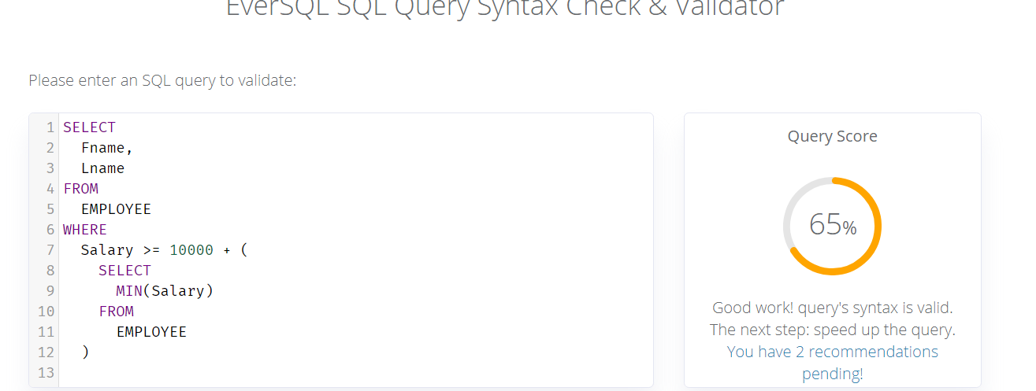

**Question 4 (Chapter 9) Carry out the 9 (nine) steps of the ER-to-Relational mapping algorithm on the ER diagram of following figure (An ER diagram for an AIRLINE database schema). Number / highlight as step 1,2, etc. Briefly explain each step, if possible.**

An e r diagram of an Airport database schema. The entity, Airplane is related to Airplane type by type. Airplane has a key attribute, Airplane i d and Total no of seats. Double lines connect the entity Airplane with Type relationship box. Cardinality ratio from Airplane to Airplane Type is N:1. Airplane Type has the attributes, Type name, Maximum seats, and Company. Type name is the key attribute. Airplane type is related to airport by can land attribute. Airport has the attributes, Airport code, City, State and Name. Cardinality ratio from Airplane Type and Airport is N: M. Airport is linked to Flight leg through the attributes, Departure Airport and Arrival Airport. Departure airport has the attribute scheduled d e p time. Arrival airport has the attribute, scheduled arrival time. The relation, Departure Airport between Airport and Flight leg has a cardinality ratio 1: N. The relation, Arrival Airport between Airport and Flight leg has the cardinality ratio, 1:N. Flight leg is placed within double rectangles and has a key attribute, leg number. Double lines connect to the Flight leg from Departure and Arrival attributes. Flight Leg is related to Flight by an identifying relationship, Legs. The cardinality ratio from Flight leg to Flight is N: 1. Flight is related to Fare by the identifying relationship fares. Flight has the attributes, number, airline, and weekdays. Number is the key attribute. Cardinality ratio from Flight to Fare is 1: N. Fare has the attributes, Code, Amount, and Restrictions. Code is the key attribute. An instance of flight leg is assigned to Airplane from the Leg instance entity. Leg instance is a weak entity. It has the attributes date and Number of available seats. Date being the key attribute. The cardinality ratio from Flight Leg to Leg instance is 1:N. Cardinality ratio from Airplane to Leg instance is 1:N. Leg instance is related to airport by Departure time and Arrival time. Cardinality ratio from Leg instance to Airport through the Arrival time relation is N:1 and ratio from Leg instance to airport through departure time relation is also N:1. Entity seat is related to Reservation and the cardinality ratio is N. It has a key attribute of seat number. The reservation entity has the attributes, customer name and customer phone.   The relationship box is related to leg instance and has a cardinal ratio of 1.  A note below the diagram reads, A Leg is a nonstop portion of a flight. A LEG INSTANCE is a particular occurrence of a LEG on a particular date.

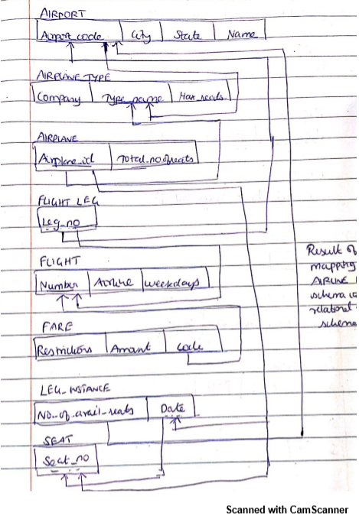

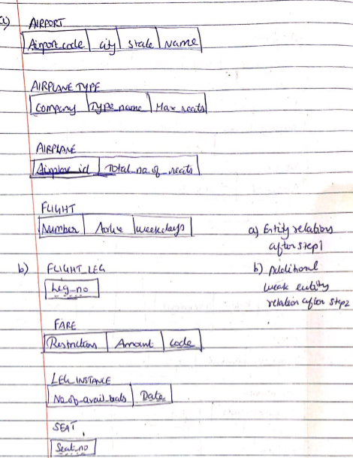

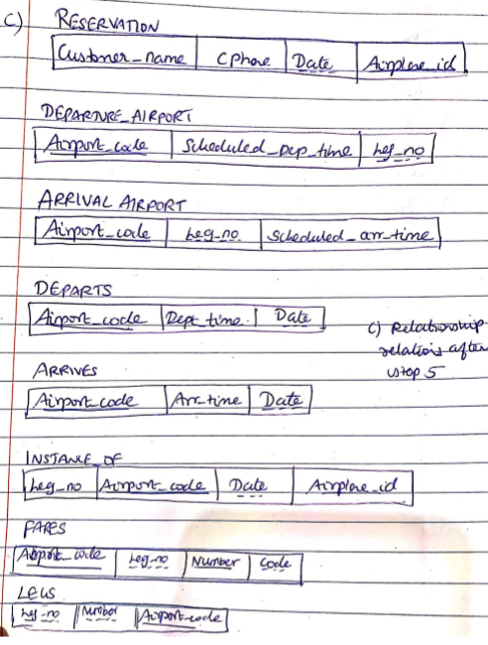

***Step 1: Mapping of Regular Entity Types***

Create the relations AIRPORT, AIRPLANE_TYPE, FLIGHT and AIRPLANE in the relational schema to the corresponding regular entities in the ER diagram.

Airport_code, Type_name, Number and Airplane_id are the primary keys for AIRPORT, AIRPLANE_TYPE, FLIGHT and AIRPLANE as shown in above ER diagram.

***Step 2: Mapping of Weak Entity Types***

* It Includes the primary key Airport_code of the AIRPORT relation as a foreign key attribute of FLIGHT_LEG.

The primary key of the FLIGHT_LEG relation is the combination { Airport_code, Leg_no} because Leg_no is the partial key of FLIGHT_LEG.

* It Includes the primary key Number of the FLIGHT relation as a foreign key attribute of FARE.

The primary key of the FARE relation is the combination { Number, Code} because Code is the partial key of FARE.

* It Includes the primary key Airplane_id of the AIRPLANE relation relation as a foreign key attribute of LEG_INSTANCE.

The primary key of the LEG_INSTANCE relation is the combination {Airplane_id, Date} because Date is the partial key of LEG_INSTANCE.

* It Includes the primary key Airplane_id of the AIRPLANE relation as a foreign key attribute of LEG_INSTANCE and partial key Date of the LEG_INSTANCE relation which in turn will be foreign key attribute for RESERVATION.

The primary key of the LEG_INSTANCE relation is the combination { Airplane_id, Date, Seat_no} because Seat_no is the partial key of RESERVATION.

***Step 3: Mapping of Binary 1:1 Relation Types***

For each binary 1:1 relationship type *R* in the E R schema, identify the relations *S* and *T* that correspond to the entity types participating in *R.*

There is no 1:1 relationship exists in above ER diagram.

***Step 4: Mapping of Binary 1:N Relationship Types***

In above ER diagram, 1:N relationship types exists for DEPARTURE_AIRPORT, ARRIVAL_AIRPORT, DEPARTS, ARRIVES, TYPE, ASSIGNED, INSTANCE_OF and FARES.

AIRPORT to FLIGHT: 1:N

FLIGHT to FLIGHT_LEG: 1:N

FLIGHT to FARE: 1:N

FLIGHT_LEG to LEG_INSTANCE: 1:N

AIRPLANE_TYPE to AIRPLANE: 1:N

AIRPLANE to LEG_INSTANCE: 1:N

LEG_INSTANCE to SEAT: 1:N

***Step 5: Mapping of Binary M:N Relationship Types.***

The M:N relationship type CAN_LAND from the E R diagram is mapped by creating a relation CAN_LAND in the relational database schema. The primary keys of the AIRPORT and AIRPLANE_TYPE relations are included as foreign keys in CAN_LAND relation.

***Step 6: Mapping of Multivalued attributes***

For each multivalued attribute A, create a new relation R. The primary key of R is the combination of A and K (foreign key). If the multivalued attribute is composite, it include its simple components. In above ER diagram of airline database does not have any multi value attribute.

***Step 7: Mapping of N-ary Relationship Types***

The relationship type INSTANCE OF in the ER diagram. This can be mapped to the INSTANCE OF relation shown in the relational schema, whose primary key is the combination of the four foreign keys {Airport_code, Airplane_id, Date, Leg_no}

The relationship type RESERVATION in the ER diagram. This can be mapped to the RESERVATION relation shown in the relational schema, whose primary key is the combination of the three foreign keys {Airplane_id, Date, Customer_name}

***Step 8: Options for Mapping Specialization or Generalization***

This step is not applicable for above ER diagram.

***Step 9: Mapping of Union Types***

For mapping a category whose defining superclass have different keys, it is customary to specify a new key attribute, called a surrogate key

This step is not applicable for above ER diagram.